Week 1, Project1
July 17, 2019

Amazon's Data Needs
Introduction
Amazon is an international company based in Seattle in American. It started in 1994 by an American entrepreneur Jeff Bezos as online retail industry, digital streaming, AI, and cloud computing. It is among the largest technology companies in the world and the most prominent online retailer in the world. It is one of the largest cloud-based online service providers operating on a pay-as-you-use basis. Amazon has been expanding to various business portfolios. Amazon began as an online bookstore and has now extended into one of the largest enterprise in the world.
It has a track record as one of the fully funded entities providing multiple and series of services across the globe. It can provide adequate resources to facilitate the fast-growing user requirements. Amazon is one of the leading companies on earth with a prominent number of customers accessing its services on an online platform.
Its diversification to technology and into various industries in the market has made it a big data analytics company (Cook, 2018). It among the top earners in terms of revenues in the world has the most sales in the e-commerce industry and is classified as a big four technology company, together with Google, Apple, and Facebook. This report discusses Amazon's company in terms of its business operations, data requirements, and data needs.
The Business
Amazon has a diversified venture in the global market. It offers varieties of both goods and services to customers irrespective of their geographical location across the globe. It is a large company that has ventured into the technology sector heavily and therefore produces huge volumes of data. The data has necessitated an intensive variety of programs and personnel to handle the fast-growing empire. Amazon is a customer-focused company; all its business strategies are aimed at improving the relationship between clients and the company, and this will, therefore, result in fast growth as a result of a large membership.
Business mission: The mission of the company is based on three main points: low prices, best selection, and the best convenience to its customers. The company strives to offer its customers with the preeminent products, a wide range of goods and in the most convenient way (Cloud, 2011). In the e-commerce industry, the company focuses on satisfying the needs of their clients in the most convenient way. The concept of a competitive business structure is well captured in the mission of the company. Therefore Bezos and the team meant well for the company from the word goes; it defines a thriving business not by wording but by the actualization of policies and ideas.
Information systems: Amazon is one of the biggest companies in technology. They boast of Amazon web services, a cloud service that operates from global data centers. Amazon is a highly advanced company in the technology sector and has one of the best technology systems in the world. Amazon produces high volumes of data due to the high number of clients. They possess the ability to handle those huge amounts of data using their information systems.
Organizational structure: Due to its large nature, Amazon operates in departments. The company has more than 600,000 employees whose management is decentralized. Its main composition is function-based. Each function consists of a group of employees and a manager in charge of the department and the function (Chen, Schütz, Kazman & Matthes, 2016).
Culture: The corporate culture of Amazon is based on pushing employees to come up with new and fresh ideas that aid the company to grow its creativity and innovation in the market. Through culture, Amazon has become one of the most innovative companies in the world and prides itself as a leading company in the technology sector. Amazon's culture aligns with its mission, a customer-centric company.
Infrastructure: Amazon sells its goods and services online. It means that consumers can access them anywhere in any place if they have internet access. They, however, own multiple warehouses where they store their inventory. Aside from the warehouses, Amazon also has cloud computing infrastructure and mega distribution centers. The kind chain existing between the supply terminuses to customary section is so fast and reliable across the globe, and this has profiled Amazon as a reliable partner to all customers.
Purpose of the data: In the e-commerce industry, data analysis is vital. They collect huge amounts of data, including customers, merchants, and all the traffic in their systems. Amazon has various data analytics systems that make it easy to handle huge volumes of data they collect every day (Cook, 2018). The company has to collect real-time data on its customers' purchasing behaviors for the e-commerce industry, and digital streaming site. Amazon has to collect data on watch history, watching analytics of all their content, and for cloud computing, real-time data analysis, and storage for all their clients. Amazon is a company that depends on data for predictive analysis to its clients, exploring consumer wants and preferences and acts as data analytic for other firms and consumers.
Data Requirements
Business and organizational policies: Amazon's policy is to be a customer-centric company that prides itself on meeting all the demands and preferences of its customers. With such a policy, they need data on the customers' preferences to act on it for better services. Customer preferences include customers' purchase behaviors, frequencies, likes, and tendencies. The Amazon management has policies that guide all the departments across the globe-spanning from the administration, financial, supply, it, procurement, and others. These policies have to be adhered to with lots of seriousness, and this ensures that every partner be it employee and customers follow the proper procedure to ensure massive satisfaction.
Security: In the e-commerce industry, the most common means of payment are online payments such as credit cards, PayPal, debit cards, etc. (Cloud, 2011). For any payment, Amazon must be willing to provide a secure platform for payments. As part of US laws, all companies are provided to secure their client's data. The security of their data is a data need for Amazon for both compliance and cybersecurity.
Functional features: Amazon has invested in four major industries, e-commerce, digital streaming, AI, and cloud computing. All the technological platforms require sophisticated data management and analysis for proper functioning (Chen, Schütz, Kazman & Matthes, 2016). For example, for a customer using their online retail platforms. Amazon uses the data on the customer's product visits and historical purchase to suggest to them similar products they might need. All of Amazon's significant departments depend on data for operation.
Currency: Amazon is a worldwide organization. It accepts more than ten different currencies of the world. The company needs data on payment systems and the location of the customers to determine the currencies acceptable for payments. It, therefore, needs data on location for determination on what is the best currency their clients can pay using.
Consistency: This refers to how consistently the company requires the data for its day-to-day operations. First, Amazon, as stated above, relies on the data it produces for marketing purposes, decision-making, and better customer services. Amazon being a big analytics company and a big data hub, it consistently requires data for day-to-day operations (Cook, 2018). It needs to advise its clients on what goods are related to the ones they are buying. Amazon needs to store securely and analyze multiple gigabytes of data produced by their clients that use their AWS.
Adaptability: Due to the ever-changing customer needs, Amazon needs data to keep up to date with the current trends and procedures. The current trends in customer purchase behavior can only be provided by the data o their purchase history and trend. It is this data that helps Amazon determine the trends for better decision making.
Performance: The performance of a business is tied to the business strategy. Before making any strategy, a company will be interested in assessing its current state, examining its level, and how to achieve the standards the company needs. To know the state of the company, it needs data on its sales statistics, clients, revenues, costs, etc. for proper analysis and decision making on the strategy to be applied (Cloud, 2011). Amazon uses a similar approach. Analyzing its current position and using the available data to estimate its performance and potentials.
DATA MODEL
With the different levels of data, Amazon has a complex data model due to its high number of partners that are involved in its business model. Amazon has customers' information, payment information, merchant's information, delivery, and supply data. The company also has third parties such as media owners streamed via its digital streams and cloud computers using their AWS services. Amazon's complexity of data involves the interactions between the buyers and the sellers.
A simplified flowchart starts with sending an inventory where it is then sent and channeled closed to the customers. The customer then orders the products, and the company identifies the product and ship. The customer will then make enquiring, and the company responds through either a call or an e-mail. The flowchart can be demonstrated as follows:
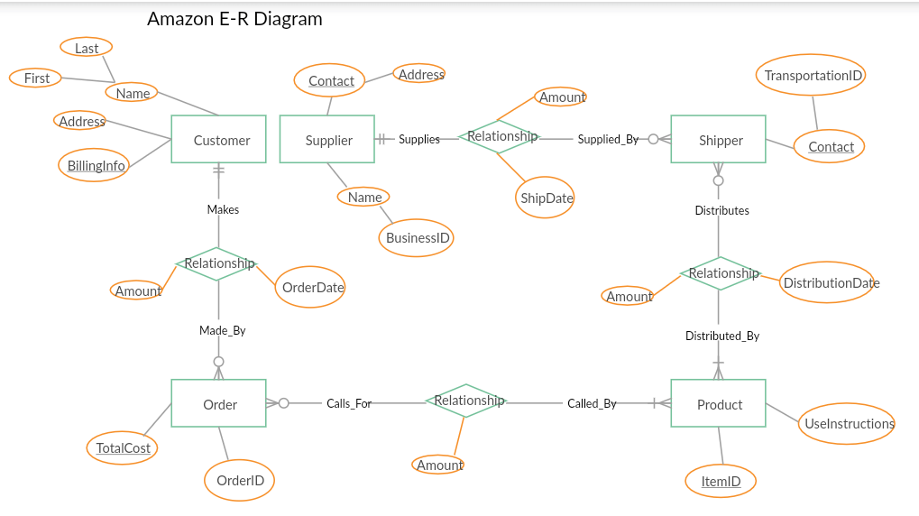
Chart 1: Amazon E-R diagram

Chart 1: Amazon E-R diagram
From the above diagram, we note that the primary keys involved in Amazon data are the customers, suppliers, shippers, products, and the order. The foreign keys of the data models are details about the customer, payments, and relationships between each of the primary keys in the model. So many factors are considered in the order of a customer. Considering that Amazon has many clients, it had huge data needs that are solved using big data analytics.
Data operations management
The productivity of Amazon solemnly depends on data operations management, which is intertwined with the decisions, and the criteria used to manage factors of operations. From the CEO's message, Amazon is one of the fast-growing companies in the globe, and the management controls its excellent status. With the use of current technology, the company has realized some tremendous results in terms of profits and growth. All these success factors can be attributed to the following strategic decisions on operations:
The design of goods and services has to be maintained at a bar. It implies that Amazon has to fight hard to ensure that the respective consumers can reach the services and goods offered, although the company is rapidly expanding globally. Also, this means that the company has to move in tandem with technological advancements to maintain the competitive nature of the business.
The decision by the management should be of high quality. It ensures that customers get precisely what they have ordered because it is online commerce. It also translates to the space given to employees to unleash their innovative power. Most of the management understands the importance of being a leader, not a manager. A leader will stand in to appreciate every single effort by the management in terms of decision making and giving the junior employees the space to grow businesswise and understanding the importance of self-discipline. All these factors have been incorporated to realize the goal of Amazon as a global business firm.
Amazon has some well-designed policies that counter the problem of the locality of the new business firm growing globally. The decision on where and why the company should set up branches need to be looked at in a manner that will reach the targeted audience using minimal resources. The firm has a team of the market assessment teams that do a pilot study in the market before rolling up the business. It will, therefore, mean that the management has to sit with the relevant stakeholders and incorporate all the innovations and technologies to ensure that not every individual customer suffers as a result of unfortunate proximity of business entity.
Another critical thing is on supply chain management system. It implies that the flow of goods and services from Amazon to the global customers should be done in a well-organized manner, and all these require proper automation of assets and supply policies. It will, therefore, beg on proper communication and tracking of movement of goods and services from the suppliers to the customers, and this can be done by sharing IT assets with some proper policy protocols.
Inventory management is another crucial thing to look at. It can be inventory ordering and holding, which means that the interphase between ordering and holding has to be constant to ensure that there is no gap left on supply. Amazon uses the finished goods inventory concept to address the idea of supply chain management. It implies management should stand in with the supply chain manager in ensuring a timely delivering by providing that there is the availability of adequate finances and workforce to facilitate proper deliveries.

Data security management
Amazon has a bulk of data that needs to be well taken care of. It is seen achieved through a cloud management system commonly known as VEEAM software that is incorporated as virtual, physical, and cloud-based techniques. It means that protected from damage and unauthorized access. The IT department is working on a 24 hours check o ensure that data is well secured across the globe. The automated system has o be regularly maintained through cloud-based monitoring techniques via VEEAM software. This software has five unique features; these include verified recoverability, no data loss, complete visibility, and leveraged data.

The cloud-based platform can be presented in the following platform.
Visibility and monitoring

cloud | saaS | Physical

Backup and recovery | Replication and failover

Data labs

Universal APIs

The cloud-based data requires authentic passwords and fingerprints to access, to amend, and to recover the lost data. It means that the software takes care of data from the initiation stage, order stage, delivery, and the same data can be stored in case of any enquiring it can be accessed through the internet. The VEEAM software allows the maintenance of virtual data, and any amendments are visible to customers across the globe on an online platform.
Master data management
Amazon is a fast-growing company and therefore means it should have a proper surveillance technique to counter the global market. The data is inclusive of the following units; sales, marketing, accounting, human resource, and production but always, management keeps their data. So the central management unit is mandated to oversee the synchronization of data and maintaining the quality on stake. Another critical process is on data structuring, which requires sophisticated software, and it has to undergo such rigorous technical procedures. The master data management is inclusive of data architectures, processes, and control mechanisms. These concepts have to be coordinated jointly to facilitate analysis of interdepartmental data reports.
Conclusion
Amazon is one of the leading and the world's largest cloud-based company fully funded with ten years of cloud-based experience. It is one of the most sophisticated and most advanced cloud providers operating across all the corners of the globe. With its financial status, Amazon is sufficiently stable; the financial entity that can support any branch with a steady supply of cash. Most of the world technocrats, businesspersons, and intellectuals are direct beneficiaries. It's one of the leading pools of academia ranging from financial, managerial, supply and technological fields, and it fully depends on data for decision-making, strategy planning, and other forms of planning. Its customers, through the various customer orders placed, purchase history, produce the data available, and website visits. With such data, they can analyze customer dynamics and trends in the market.

References
Chen, H. M., Schütz, R., Kazman, R., & Matthes, F.. (2016). Amazon in the air: Innovating with big data at Lufthansa. In 2016 49th Hawaii International Conference on System Sciences (HICSS), 5096 - 5105.
Cloud, A. E. C. (2011). Amazon web services. Retrieved November, 9(2011).
Cook, B. (2018). Formal reasoning about the security of amazon web services. International Conference on Computer-Aided Verification, 38 - 47.
Graham, B., Dodd, D. L. F., & Cottle, S. (1934). Security analysis (pp. 44-45). New York: McGraw-Hill.
Pipino, L.L., Lee Y.W., & Wang, R.Y. (2002). Data quality assessment. Communications of the ACM, 211 - 218.
Shaikh, F. B., & Haider, S. (2011, December). Security threats in cloud computing. In 2011 International Conference for Internet Technology and Secured Transactions (pp. 214-219). IEEE.

